

**Project Report**

Submitted By

Muzaffar Iqbal

Submitted To

Aatka Ali

Project Name

Traffic Control system

Contents

**ABSTRACT:** 2

**INTRODUCTION:** 3

**CIRCUIT DIAGRAM:** 3

**COMPONENTS USED:** 3

**COMPONENTS DESCRIPTION:** 4

**D Flip-Flop** 4

**AND GATE:** 4

**OR GATE:** 5

**NAND GATE:** 5

**CIRCUIT DESIGN;** 6

**WORKING:** 6

LIMITATIONS: 7

**REFERENCES:** 8

# **ABSTRACT:**

Traffic light control systems are widely used to monitor and control the flow of automobiles through the junction of many roads. They aim to realize smooth motion of cars in the transportation routes. However, the synchronization of multiple traffic light systems at adjacent intersections is a complicated problem given the various parameters involved. Conventional systems do not handle variable flows approaching the junctions. In addition, the mutual interference between adjacent traffic light systems, the disparity of cars flow with time, the accidents, the passage of emergency vehicles, and the pedestrian crossing are not implemented in the existing traffic system. This leads to traffic jam and congestion. We propose a system based on PIC microcontroller that evaluates the traffic density using IR sensors and accomplishes dynamic timing slots with different levels. Moreover, a portable controller device is designed to solve the problem of emergency vehicles stuck in overcrowded roads.

# **INTRODUCTION:**

Traffic control is one of the most important technical means to regulate traffic flow, improve the congestion, and even reduce emissions. Its progress and development has always been accompanied by the development of information technology, computer technology, and system science. The self-adaptive control system can adjust the signal timing parameters in real time according to the control target of the manager (such as the minimum delay of the intersection) and the arrival characteristics of the traffic flow at the intersection. Compared with timing control and actuated control, the self-adaptive control system can make better use of the overall traffic capacity of the road network and effectively improve the efficiency of road network traffic.

# **CIRCUIT DIAGRAM:**

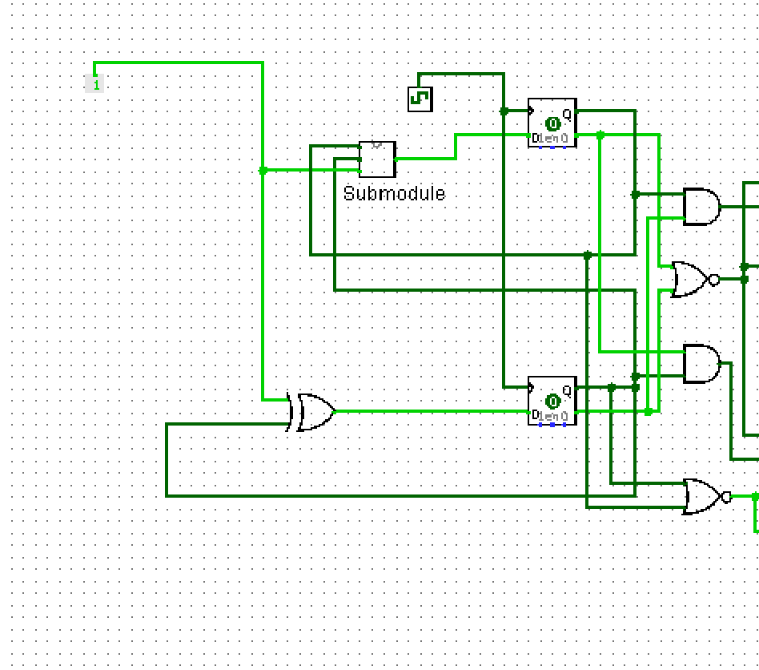

Figure 1: Circuit diagram

# **COMPONENTS USED:**

* D-flip-flops
* 2-to-1 multiplexer
* AND gate
* OR gate
* NAND gate
* Input & output indicators
* clock

# **COMPONENTS DESCRIPTION:**

**D Flip-Flop**

The D flip-flop is a two-input flip-flop. The inputs are the data (D) input and a clock (CLK) input. The clock is a timing pulse generated by the equipment to control operations. The D flip-flop is used to store data at a predetermined time and hold it until it is needed.

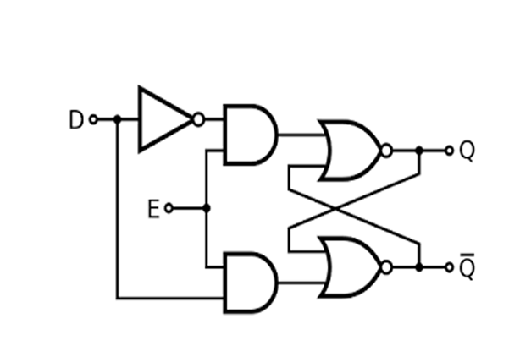

Figure 2: D-flipflop and its excitation table

## **AND GATE:**

An AND gate is an electrical circuit that combines two signals so that the output is on if both signals are present. It is a basic digital logic **gate** that implements logical conjunction (∧) from mathematical logic.

Figure 4: AND gate

## **OR GATE:**

An **OR gate** is a logic **gate** that performs logical OR operation. A logical OR operation has a high output (1) if one or both the inputs are high.

Figure 5:OR gate

## **NAND GATE:**

A NAND gate is a logic gate which produces an output which is false only if all its inputs are true thus, its output is complement to that of an AND gate.

Figure 6: NAND gate

# **CIRCUIT DESIGN;**

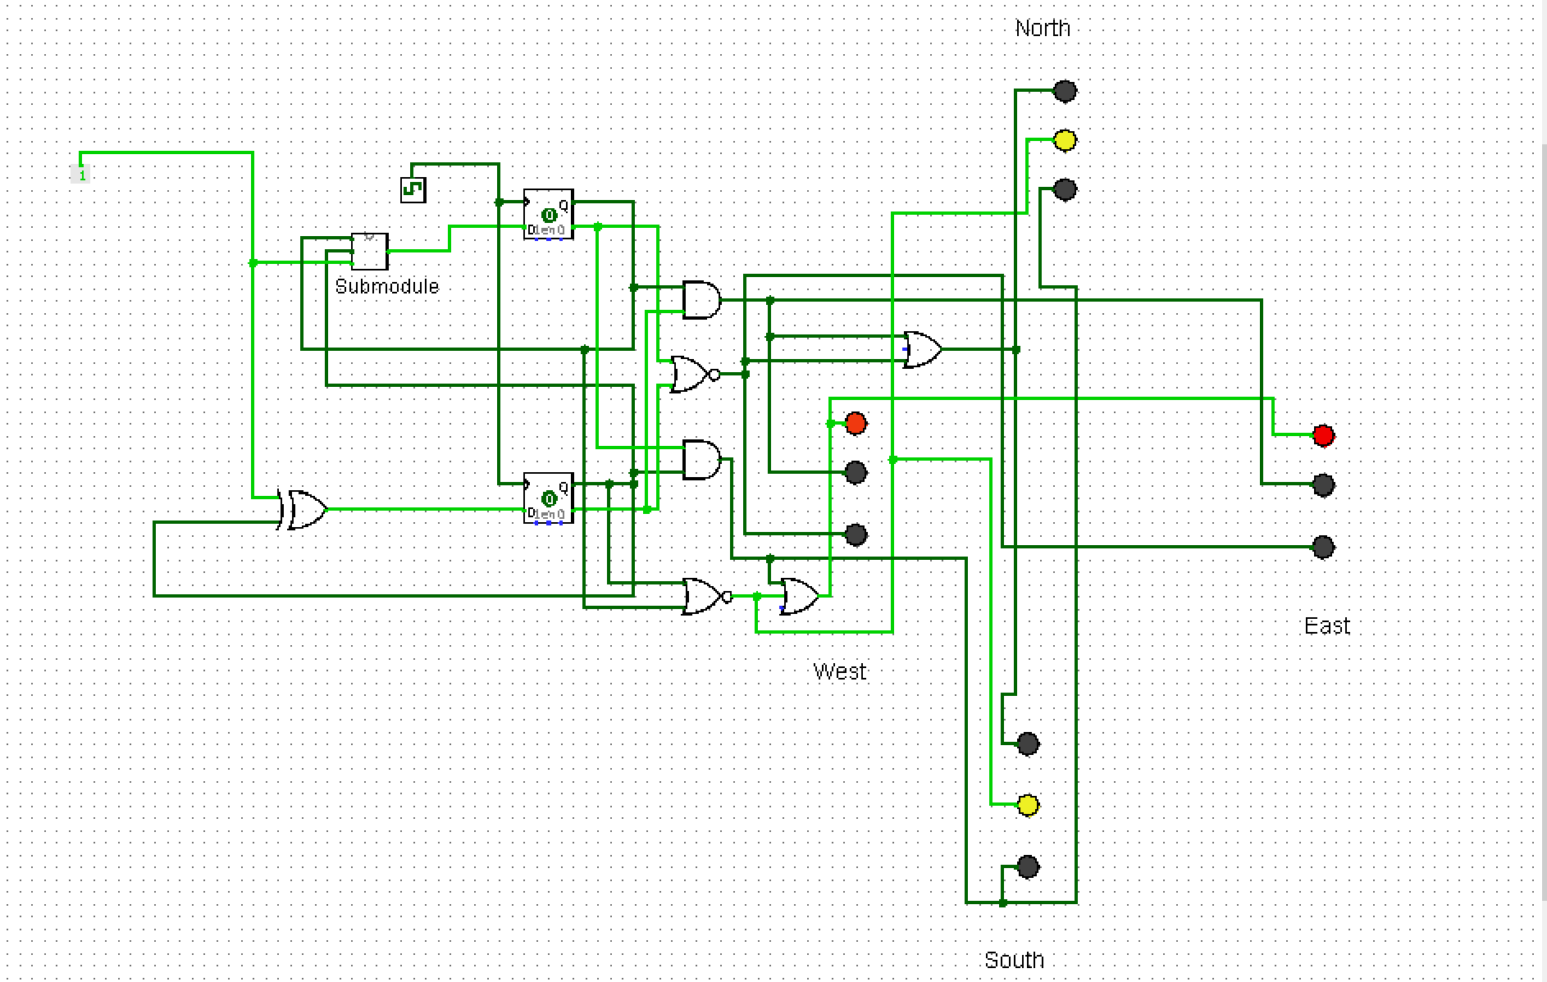

# **WORKING:**

The logisim circuit controls the traffic control for four direction (North, South, West, East).The circuit make use of D Flip-Flop for the working of the system. The project shows how a 4-way junction traffic light works and the lights at every junction change colors with time (depending on clock cycles). The north and south lights are in sync with each other and opposite to the east and west lights.Our logisim circuit is a simulation of a 4 way traffic control system, where the north and south traffic lights work together and the east and west lights work together. The circuit doesn't require any manual input and works entirely on clock pulses. To run the circuit, first go to simulation and reset the simulation and then enable the clock ticks. The frequency of the clock can be adjusted. The traffic lights change color according to the clock pulses

# LIMITATIONS:

As we have used the clock pulse in our circuit which is basically a sequential logic circuit. In the interval of counting there will be some delay i.e., the time 3s will be slightly greater than 3s. However, this delay is very minor and can be ignored.